Shane Riegodedios

Dr. Antov

Intro to Algorithm Analysis

March 9th, 2017

Introduction to Algorithm Analysis

1. 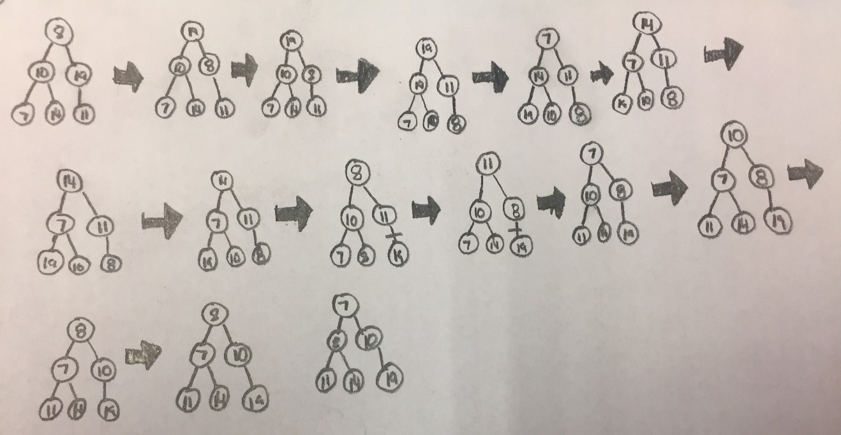

${n= 10}^{} 27 swaps c=0.27$

$n= {10}^{2} 2262 swaps c= 0.2262$

$n= {10}^{3} 214212 swaps c=0.214212$

${n=10}^{4} 21440712 swaps c=0.21440712$

$c_{I} ∈0.214$

${n= 10}^{} 34 swaps c=3.2$

$${n= 10}^{2} 671 swaps c=3.35$$

$${n= 10}^{3} 9919 swaps c=3.31$$

$${n= 10}^{4} 132919 swaps c=3.32$$

$$c_{H} ∈3.34$$

$$n ≤20$$

Insertion sort is faster.

3.

The test results show for small values, InsertionSort is faster but over 20, HeapSort is much more faster to use.